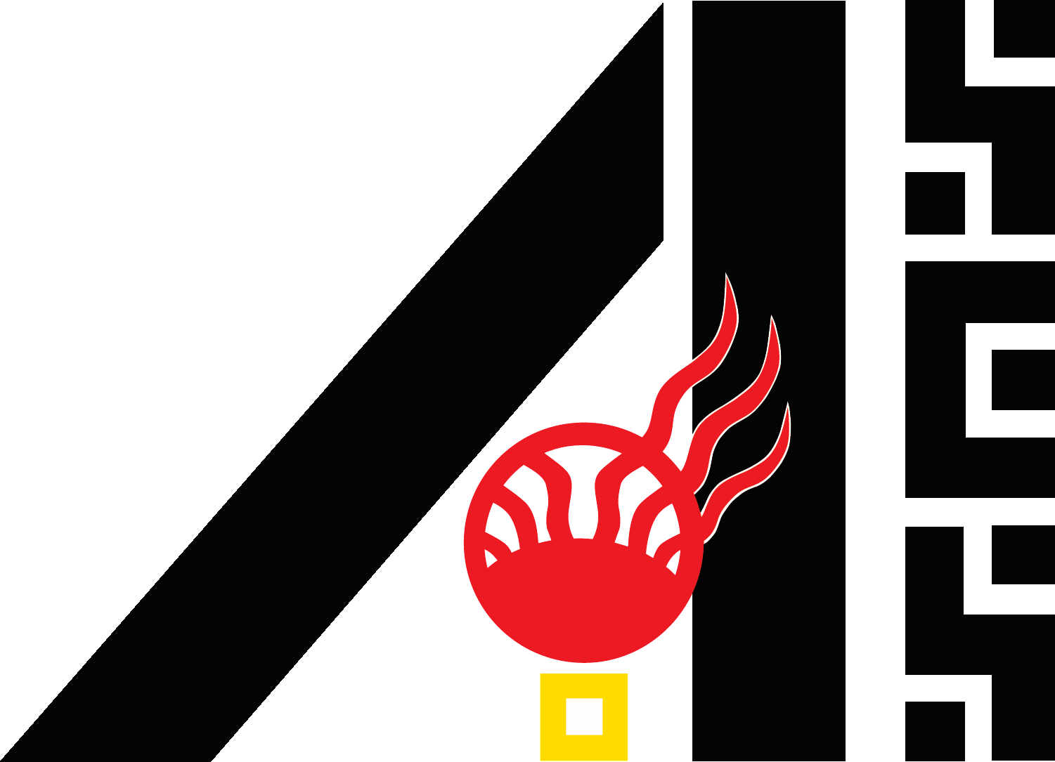
Energy Challenge
STUDENT/PARENT LIABILITY AND MEDIA RELEASE FORM

The student, sponsoring teacher, and parent/guardian hereby agree that they accept the following conditions:

1) I shall abide by ALL fair rules and procedures or risk disqualification.
2) I understand that sponsors, officials, & volunteers of the Energy Challenge are not responsible for loss/damage, or failed uploads of materials to the project. It is recommended that each student take prudent precautions to prevent any theft, loss, or damage to his/her materials and to protect the copyrights, if any, of their material.
4) I will make backup copies of all materials, forms, documents submitted.
5) I agree that should my entered project win in its category, that my video and slideshow may be displayed on the AISES website.
6) I (the teacher) agree to sponsor the student and assume responsibility for compliance with ALL existing rules for the current year.
7) I (the teacher) agree to conduct a safety review of the project.
8) I understand that the decision of Energy Challenge officials is final in the selection of winners. I shall not be entitled to the contact information of Energy Challenge Officials nor shall I attempt to contact any officials concerning selection of winners. The term “Energy Challenge officials” includes but is not limited to any and all judges involved in the selection of winners.
9) I understand that any opinions expressed by judges and/or award donors are solely those of that individual or organization and do not represent the opinions of AISES.
10) I give permission to use appropriate information about me for public purposes (including photos, videos, or likenesses that may be used by Energy Challenge or sponsors of awards) for the purposes of illustrations, advertising, or publication in any manner. I also consent to use of my name therewith. No personal identifying information will be made public such as address or birthdates, etc.

The AISES Energy Challenge is a prestigious event and your participation is newsworthy. The organizations and/or businesses sponsoring awards may want to publicize their involvement in such an important science and engineering competition by using photographs/information about you. Your cooperation will help make it possible for other promising young students to get involved in research.

_____________________________________________ _____________________________________________
Teacher/Sponsor (Circle One) Name Printed Teacher/Sponsor Signature

_____________________________________________ _____________________________________________
Student Name Printed Student 2 Name (if a team) Printed

_____________________________________________ _____________________________________________
Student Signature Student 2 Signature

_____________________________________________ _____________________________________________
Parent/Guardian Name Printed Parent/Guardian of Student 2 Printed

_____________________________________________ _____________________________________________
Parent/Guardian Signature Parent/Guardian of Student 2 Signature

_____________________________________________ _____________________________________________
Student 3 Name (if a team) Printed Student 4 Name (if a team) Printed

_____________________________________________ _____________________________________________
Student 3 Signature Student 4 Signature

_____________________________________________ _____________________________________________
Parent/Guardian of Student 3 Name Printed Parent/Guardian of Student 4 Printed

_____________________________________________ _____________________________________________
Parent/Guardian of Student 3 Signature Parent/Guardian of Student 4 Signature

AISES MISSION STATEMENT:
The American Indian Science and Engineering Society (AISES) is a national, nonprofit organization focused on substantially increasing the representation of American Indians, Alaska Natives, Native Hawaiians, Pacific Islanders, First Nations and other indigenous peoples of North America in science, technology, engineering and math (STEM) studies and careers.

