2017 AISES National American Indian
Virtual Science & Engineering Fair

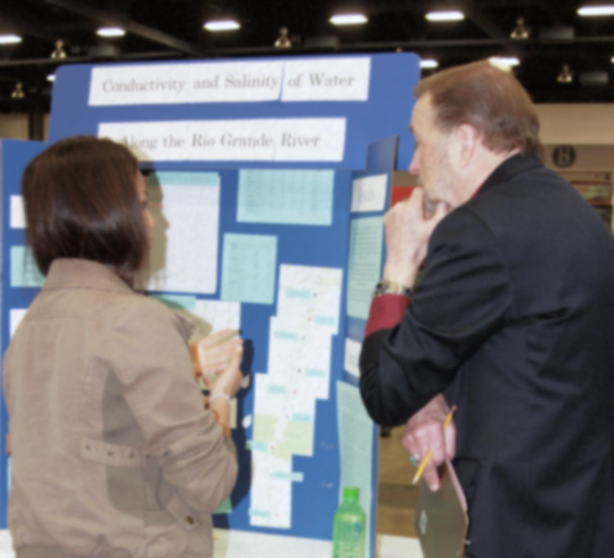
Junior Division
Policies,
Procedures,
and
Rules

NAIVSEF POLICIES, PROCEDURES, AND RULES

TABLE OF CONTENTS

- About Science Fairs 1
- Fair Standards 1
- NAIVSEF Mission and Ethics Statement 2
- Multiple Science Fair Entries 2
- NAIVSEF Project Registration, Registration Fee, and Submission Process 3
- NAISVEF SRC and the SRC Review Process 7
- NAIVSEF Judging Process 8
- Scoring Criteria 10
- Announcement of Winners 12

About Science Fairs
About AISES’ NAIVSEF
The American Indian Science and Engineering Society’s (AISES) National American Indian Virtual Science and Engineering Fair (NAIVSEF) is a Society for Science and the Public (SSP) affiliated science fair and as such is part of the larger SSP fair network. The NAIVSEF differs from other SSP-affiliated fairs in that it is a “Virtual Science Fair” and is serving as a pilot to explore the feasibility of such a forum. The NAIVSF allows students from 5th-12th grade to participate in its event. There are two categories for entrants, high school (defined as grades 9-12) and middle school (defined as grades 5-8). Only high school students (grades 9-12) meeting ISEF who meet and satisfy ISEF rules may go on to participate in the ISEF. https://student.societyforscience.org/rules-all-projects
SSP Affiliated Fairs
An SSP-affiliated science fair is a science competition that is a member of Society for Science & the Public’s (SSP) fair network. These competitions exist in nearly every state in the U.S. and more than 70 countries, regions, and territories.
The fair network currently consists of 352 fairs within the United States and its territories and 110 international fairs. Fairs affiliate with SSP primarily to bring finalists to the Intel International Science and Engineering Fair (ISEF), held each May. For more information about the ISEF, please visit their website at: https://student.societyforscience.org/intel-isef
Fair Standards
Intel ISEF Rules/SRC:
It is a requirement that affiliated fairs, such as the NAIVSEF, adhere to the International Rules for Precollege Science Research: Guidelines for Science and Engineering Fairs (Intel ISEF Rules) and that students, teachers and parents are informed about these requirements so that they use Intel ISEF forms from the start of research. Students that do not receive the appropriate approvals or complete the necessary Intel ISEF forms in the proper timeline may not qualify for competition at the Intel ISEF.
The fair director must appoint a Scientific Review Committee (SRC) that consists of a minimum of three members. The SRC must include at least one each of: a) biomedical scientist (e.g., Ph.D., M.D., D.V.M., D.D.S., D.O.), b) science educator, and c) another member who may, but is not required to be, a biomedical scientist or a science teacher.
These SRC members must be registered with Society for Science & the Public. Fair directors are required to fill out a form after their fair stating information about the SRC’s activities, such as the group’s meeting schedule and any problems the SRC encountered during reviews.
Judging and student eligibility
Affiliated fairs must recruit and manage a team of judges to select the projects to advance to the Intel ISEF. The judging process must be transparent and avoid any appearance of partiality or conflict of interest. Projects may be individual or team projects in any combination.
Each student may enter only one project that covers research done over a maximum, continuous 12-month period between January and May of the current Intel ISEF year. Team projects are limited to two or three members.
Multiple Science Fair Entries
Students may not compete in both an Intel ISEF-affiliated state fair and the NAIVSEF. Participation in other fairs at the local and/or regional fair level is acceptable, but students cannot participate in both their state fair AND the NAIVSEF.
Mission
The National American Indian Virtual Science and Engineering Fair serves American Indians/Alaska Natives/Native Hawaiians (AI/AN/NH) in grades 5-12. Held annually, NAIVSEF provides an opportunity for students to actively participate in a science-based learning environment and create science projects and conduct scientific research that can be shared with peers, educators, and other Native role models. Students and educators come from across the United States, representing hundreds of tribal nations to participate in this prestigious event.
This national science fair serves as a catalyst for expanding young minds and creating an arena for students to showcase their research and enhance their knowledge around a variety of STEM (science, technology, engineering and mathematics) fields.
Ethics Statement
Scientific fraud and misconduct are not condoned at any level of research or competition. This includes plagiarism, forgery, use or presentation of other researcher’s work as one’s own and fabrication of data. Fraudulent projects will fail to qualify for competition in affiliated fairs and the Intel ISEF. The AISES reserves the right to revoke the recognition of a project subsequently found to have been fraudulent.

NAIVSEF Project Registration, Registration Fee, and Submission Process
Registration
Students must register for this fair online. The process is the same for high school and middle school students/teams. Registrations are considered complete when all required forms and documents have been completed and uploaded by posted deadlines. For time/date stamp considerations, the completion date/time is used to determine when the entry was received. This event is limited to 100 high school projects and 75 middle school projects. The system will not allow additional registrations to begin or be completed once those numbers have been fully satisfied, thus attention to the timing and completion of the FULL registration process is important. Only in the event that a student/team is disqualified or payment is not received by the due date, will other students be allowed to submit beyond the registration deadline (AISES does not anticipate this happening). In such a situation, the most completed applications will be given consideration and allowed to submit.
The link to the AISES NAIVSEF online registration website, AISES NAIVSEF forms, links to ISEF required forms, the online ISEF Rules Wizard, and other useful information for registration can be found at: http://naivsef.aises.org/.
The first step for registration is to complete the ISEF Rules Wizard (https://apps2.societyforscience.org/wizard/index.asp) to determine what additional ISEF forms, other than the required ISEF forms (Forms 1, 1A, and 1B; also, if a continuation project, Form 7, and/or IF the student research will be conducted in a Regulated Research Institution, industrial setting or a work site other than home, school or out in the field, Form 1C.), will need to be completed by the student.
Students should print and complete all required forms. They will need to be scanned and uploaded as individual .pdf files (no other format will be accepted). Likewise, any other additional forms (as indicated by the ISEF Rules Wizard) should also be completed and prepared for upload into the online registration website. Forms MUST be in .pdf format and uploaded individually. The forms should be named by their form number, example: Form 1A, Form 7, and so on.
The second step is to download the AISES NAIVSEF Media & Liability Release form found on the AISES NAIVSEF webpage. This form must be completed and signed by the appropriate parent/guardian as indicated. This form must also be scanned and uploaded as a .pdf as part of the registration process. If you register as a team, this form must be signed by all team members and their parents.
The third step is to go online and register at the AISES NAIVSEF website: http://naivsef.aises.org/.
If you will be registering as a Team: Choose one of the team members to be the Team Leader. There can only be up to 3 students total per team. The Team Leader will register for the entire team and will provide all team member names and other information during the registration process. All students must complete their own Media & Liability Release Form. The Team Leader will be the contact for all correspondence and communication regarding the AISES NAIVSEF. An AISES NAIVSEF Media & Liability Release must be submitted for ALL team members.
Go to the APPLY NOW tab. The student (or Team Leader if registering for a team) or his/her teacher must create a new user account and enter all required information (marked with an asterisk). The student’s address and contact information must be provided. The student will create a unique username and password.
IMPORTANT! Please provide a valid e-mail address. If the student does not have an email address, the teacher’s or a parent’s may be provided. All official science fair communications will be sent via e-mail, so PLEASE be SURE that the e-mail address you provide is correct and that the email is checked regularly for email. It is not AISES’ responsibility to ensure that a student reads his or her email. It is the student’s responsibility.
Next, complete the Application Form. This will ask for the First and Last name of the student/Team Leader and the type of student (Elementary, Middle, or High School). Finally, upload all required documents:
Form 1: Checklist for Adult Sponsor / Safety Assessment Form
Form 1A: Student Checklist / Research Plan
Research Plan / Summary
Form 1B: Approval Form
AISES NAIVSEF Media & Liability Release (needed for all Team Members, if applicable)
(Optional: Other Team Member Information Form)
(Any other required forms, depending on your research and ISEF Rules Wizard results)*
*The Rules Wizard has been designed as a first step to help you determine what forms and approvals are necessary before beginning a science fair project intended for competition at an ISEF-affiliated fair or the Intel International Science and Engineering Fair. This wizard is intended to be a helping tool, but cannot account for all specifics and situations of your individual project.
Please be sure to read and review the 2017 International Rules found online at: https://member.societyforscience.org/document.doc?id=639. It is the student’s responsibility to familiarize him or herself with these rules, as it will be assumed they have done so.
All ISEF Forms are found here online: http://student.societyforscience.org/forms, please use the forms listed under the section entitled “2017 Forms”).
The ISEF Rules Wizard, used to determine additional required forms, if any, can be found at: https://apps2.societyforscience.org/wizard/index.asp.

Registration Fee
Each project entered must pay a registration fee. The fee is $10.00 per project (not per student) for Junior Division entries. A “NAIVSEF PAYMENT FORM” can be found on the AISES NAIVSEF Webpage. Please download the form and fill it in. The form must be completed and sent via email or regular mail. If emailed (must pay with credit card if you would like to email) send complete form to: asilva@aises.org. If sent via mail, send form and payment to: AISES, 2305 Renard SE, Suite 200, Albuquerque, NM 87106. Payment must be received no later than March 21, 2017. If you have any questions or concerns, see the contact info on the AISES NAIVSEF website.
If payment is not received by that date, the student may not be allowed to upload his or her materials into the NAIVSEF website platform. In the event that a student/team is not able to participate in the submission of slideshows/videos stage of the NAIVSEF, any fees paid will be refunded in full.

Submission of Science Fair Videos and Slideshows
Once a student/team has received the final approval from the AISES SRC, they may continue with their projects. Students, upon completion of their projects, may upload their Science Fair Slideshows and optional videos via the AISES NAIVSEF website. Log into the same account used to register at: http://naivsef.aises.org/.
All students must submit a slideshow i.e. MS Office PowerPoint. The slideshow cannot have more than 25 slides. A 5-10 minute video is optional. If submitted, the video cannot be longer than 10 minutes.
Video: The video should be an introduction to you and your team members, as well as a brief description of your project, why you were interested in it and what impact you hope it has in your community or world. Students may use a webcam, video recorder, or smartphones to record their video. Only the student/student team members may appear and speak in the video. The video is uploaded using the http://www.youtube.com website. It should be uploaded as a private video (this works like an unlisted phone number – only those with the youtube.com link to your video may view it). Once uploaded onto www.youtube.com, you will copy and paste the link to your video to a document (MSWord) and uploaded it as a file named “Science Fair Video Link.” The video is not scored, but it does serve to provide the judges with an introduction to the students and makes it a more personal experience.

Slideshow: The slideshow must address the following and in the order listed:
- Question/Proposal: Describe the question that you are investigating and your hypothesis, or the problem that you are going to try to solve and the outcome that you expect.
- Research: An account of the research that you have done into your chosen category, and how this has influenced your Project.
- Method/Testing and Redesign: Describe in detail how you carried out your experiment or tested your solution.
- Results: Your data and observations gathered during your experiment or testing, presented clearly with a description of any patterns or trends.
- Impact: Here you describe what impacts and/or practical implications your project may have in the larger world or what impact continued research could have for the world or your community.
- Conclusion/Report: An explanation of how your experiment or testing answers your question, or why it fails to do so, and whether or not the outcome was as you expected.
- Bibliography, References and Acknowledgements.

The slide show may photos, charts, graphs, graphics, etc. If the slideshow or video contains photos, all ISEF Rules regarding photos must be followed.

NAIVSEF SRC and the SRC Review Process
Members of the SRC are made up of a group of adults knowledgeable about regulations concerning experimentation in restricted areas. The SRC is selected per ISEF rules and regulations. The SRC reviews and approves the submitted Checklist for Adult Sponsor, Abstract, Student Research Plan (1A), including the Student Research Plan (SRP) Attachment, and Approval Form (1B), in addition to other forms that the Rules Wizard required the student to submit, for all students/teams who enter the NAIVSEF. There are two SRC Reviews before competition/submission of videos and slideshows.

Initial Review (If Required)
Before experimentation, unless a properly signed Form 1C is provided, the AISES SRC reviews and approves those experimental procedures for projects involving human subjects, nonhuman vertebrates, pathogenic agents, controlled substances, recombinant DNA, and human/animal tissue to make sure they comply with the Rules and any pertinent laws. Note: Human studies previously reviewed and approved by a properly constituted IRB do not have to be reviewed by the SRC until competition.
The SRC examines project documents for the following:
  - evidence of literature search
  - evidence of proper supervision
  - use of accepted research techniques
  - completed forms, signatures, and dates
  - evidence of search for alternatives to animal use
  - humane treatment of animals
  - compliance with rules and laws governing human and animal research
  - appropriate use of recombinant DNA, pathogenic organisms, controlled substances, tissues and hazardous substances and devices
  - appropriate documents and substantial expansion for continuation projects

After the SRC has reviewed each submitted application package, an SRC review form will be sent to the student via email. The form notifies the student, or team, whether they are approved to proceed with their experiment, approved to with proceed with minor corrections to be made, or not approved to proceed with experimentation unless significant corrections are made and forms submitted again for review.

Before research can begin, students whose projects triggered an SRC review (because their proposed research involves human subjects, vertebrate animals, and PHBA's (potentially hazardous pathogenic agents) including microorganisms, recombinant DNA, and human or animal tissue) have up to 7 calendar days to make corrections and revisions as required by the SRC. After the 7 days have lapsed, the SRC will again review all student submissions that were required to make corrections/revisions to ensure that have brought their application packages into compliance before being approved to submit their research. Students who cannot, or failed to do so, by the 7th day will NOT be allowed to participate further. (Part 2a of ISEF Form 1B)
Note: The SRC reviews projects after the research was done and before the online submission of slideshows and videos, if the research was done at a research institution and was preapproved by that institution instead of the affiliated fair SRC (a properly completed ISEF Form 1C was provided when the student initially registered). All documentation from the research institution showing approval of the project must be uploaded during the initial registration process. (Part 2b, ISEF Form 1B)
Paperwork Day
Seven (7) days, or more, before the online submission of project slideshows and optional videos can be uploaded into the NAIVSEF website, the SRC will review ALL projects’ ISEF Forms: Checklist for Adult Sponsor (Form1), Student Research Plan (1A), including the Student Research Plan (SRP) Attachment, and Approval Form (1B), plus other required protocol forms, to ensure compliance and adherence to the ISEF Rules and the SRP. In addition, the Abstract and Media and Liability Release forms will be reviewed for compliance. If all is in order and approved, Part 3 of the ISEF Form 1B will be completed by the SRC and the student will be notified that the final project has been approved and they may upload their materials on the dates provided. Student’s not approved will be notified and any registration fees already received by AISES will be refunded.
NAIVSEF Judging Process
Judging for the virtual science and engineering fair is conducted in phases. The first phase eliminates projects from continuing to the second and final phase. Scores for phases one and two are made by judge panels and are added together and submitted with comments to the lead judge in the finalist phase. The scores are submitted to a lead judge (there is a separate lead judge for high school projects and another for middle school projects) that reviews all of the panel scores for completeness, reads comments made, and then, determines final winners and places.
The first phase of judging is conducted by panel judges via a review of all relevant materials, slideshows, and forms submitted by students/teams online. Judges review these online materials independently. The goal of this first phase is to select the projects which will move on to the second judging phase. Judges review the complete online package of materials and score them using a scoring rubric that conforms to the Intel ISEF judging criteria. The second phase is the interview phase of scoring. During the interview phase, all students/teams are interviewed by the same panel of judges via telephone conference calls on the established virtual fair days.
AISES utilizes volunteer judges to review and score science projects. Project judges work in teams of two called panels. There may be several panels depending on the number of projects in the fair. However, the same panel of judges will score both phases for all projects assigned to them.
The initial scoring is conducted online and independently. The judges review the project materials, video and slideshows submitted, along with relevant forms and other documents. Once online scoring is completed, each panel is convened, via telephone conference, to discuss scores for each project they scored and to come to a consensus on the projects they wish to move to the second phase of the scoring process for the interview phase.
Finalists are notified that they have made it to the second phase and are provided with their call date/time and toll-free call-in information. They are not informed of their current score, as the interview is part of the final scoring. Only the student or team members (all must be present) are allowed to address the judge panel during the interview conference call. No other people in the room may speak to the judges or students during the interview portion of the call.
During this second phase, which occurs on the designated virtual fair days, the judge panel and student finalists convene for a 20-minute telephone conference call. Judges will ask questions that help them determine: whether participants have an understanding of the basic science relevant to their project and can understand interpretation and limitations of their results and conclusions; their degree of independence in conducting the project; their recognition of the potential impact of their project in science, society and/or economics; the quality of ideas for further research; and for team projects, contributions to and understanding of project by all members.
Following the conference call, each panel reconvenes and comes to a consensus on the interview score. Interview scores are added to the earlier-determined scores from the first phase and are then submitted to the lead judge for the age group the project belongs to.
The lead judges review all project scores and then determine winners for their assigned age group; high school or middle school. Special awards are also determined if any. Special awards are usually for specific science or engineering subjects, age, grade, or geographic areas. These are funded by various organizations and the number and types vary from year to year, as to the prizes, if any, for special awards.
Scoring Criteria
The following evaluation criteria are used for judging at NAIVSEF and by the Intel ISEF. As shown below, science and engineering have different criteria, each with five sections as well as suggested scoring for each section. Each section includes key items to consider for evaluation both before and after the interview.
Students are encouraged to design their slideshows (PowerPoints) in a clear and informative manner. Judges should examine the student forms and application submitted online and, if present, any special forms such as Form 1C (Regulated Research Institution/Industrial Setting) and Form 7 (Continuation of Projects). Considerable emphasis is placed on two areas: Creativity and Presentation, especially the Interview section, and are discussed in more detail below.
Creativity: A creative project demonstrates imagination and inventiveness. Such projects often offer different perspectives that open up new possibilities or new alternatives. Judges should place emphasis on research outcomes in evaluating creativity.
- If the project was done at a research or industrial facility, the judge should determine the degree of independence of the finalist in conducting the project, which is documented on Form 1C.
- If the project was completed at home or in a school laboratory, the judge should determine if the finalist received any mentoring or professional guidance.
- Please note that both team and individual projects are judged together, and projects should be judged only on the basis of their quality. However, all team members should demonstrate significant contributions to and an understanding of the project.
Phase One of Scoring
For Science Projects
I. Research Question (10 pts.)
___ clear and focused purpose
___ identifies contribution to field of study
___ testable using scientific methods

II. Design and Methodology (15 pts.)
___ well designed plan and data collection methods
___ variables and controls defined, appropriate and complete

III. Execution: Data Collection, Analysis and Interpretation (20 pts.)
___ systematic data collection and analysis
___ reproducibility of results
___ appropriate application of mathematical and statistical methods
___ sufficient data collected to support interpretation and conclusions

IV. Creativity (15 pts.)
___ project demonstrates significant creativity in one or more of the above criteria

V. Presentation/Slideshow (20 pts.)
___ logical organization of material
___ clarity of graphics and legends
___ supporting documentation displayed

For Engineering Projects

I. Research Problem (10 pts.)
___ description of a practical need or problem to be solved
___ definition of criteria for proposed solution
___ explanation of constraints

II. Design and Methodology (15 pts.)
___ exploration of alternatives to answer need or problem
___ identification of a solution
___ development of a prototype/model

III. Execution: Construction and Testing (20 pts.)
___ prototype demonstrates intended design
___ prototype has been tested in multiple conditions/trials
___ prototype demonstrates engineering skill and completeness

IV. Creativity (15 pts.)
___ project demonstrates significant creativity in one or more of the above criteria

V. Presentation/Slideshow (20 pts.)
___logical organization of material
___clarity of graphics and legends
___ supporting documentation displayed

Phase 2 of Scoring

The final interview provides the opportunity to interact with the finalists and evaluate their understanding of the project’s basic science, interpretation and limitations of the results and conclusions.

If the project is a multi-year effort, the interview should focus ONLY on the current year’s work. Judges should review the project’s abstract and Form 7 (Intel ISEF Continuation Projects) to clarify what progress was completed this year.

Teleconference Interview for Science and Engineering (20 pts.)

___ clear, concise, thoughtful responses to questions
___ understanding of basic science relevant to project
___ understanding interpretation and limitations of results and conclusions
___ degree of independence in conducting project
___ recognition of potential impact in science, society and/or economics
___ quality of ideas for further research
___ for team projects, contributions to and understanding of project by all members

Announcement of Winners
For the high school and middle school winners, notice will be made first to the winners and then announced on AISES website. Each student’s video (if provided) and slideshow will be posted and maintained on the AISES website for one year. Medals and cash rewards (if any) will be mailed to each winning student (and team members). A press release will also be sent out to local, national, and regional newspapers and relevant publications.
Only Senior Division Grand Award Winners will be eligible to participate in the next Intel ISEF and will represent AISES and their high school.

