About AISES
Since 1977, the American Indian Science and Engineering Society (AISES) has worked to increase the representation and participation of American Indian people – as students, professionals, mentors, and leaders—in science, technology, engineering, and mathematics (STEM) disciplines. With a rapidly expanding membership of more than 3,800 individual members, AISES sustains 189 chartered college and university chapters, 15 professional chapters, and 158 affiliated K-12 schools supporting American Indian. AISES has awarded over $10.3 million in academic scholarships to American Indian STEM students. Through scholarships and internships, workforce development and career resources, national and regional conferences, science fairs, leadership development, and other STEM focused programming, AISES is the leader in STEM opportunity for American Indians.

About the Leadership Summit
The 2016 AISES Leadership Summit will focus on building the skill and knowledge of AISES members in the realm of professional and career development – to better prepare AISES members to attain jobs and careers in the fields of STEM. This comprehensive learning experience will address building the leadership skills of approximately 125 AISES college and graduate student members and 75 professional members, including regional and national student representatives. In addition to informational sessions, there will be peer-to-peer networking, regional conference planning, a traditional closing circle, and a closing banquet.
“I learned a lot about myself as a leader, and a lot about working with my fellow AISES chapter members. I learned great motivational tactics and had a lot of fun networking.”
-Student Participant,
2013 AISES Leadership Summit

The 2016 AISES Leadership Summit will be the first of its kind! In partnership with IBM and the Mayo Clinic, AISES will host the Leadership Summit at the IBM and Mayo Clinic campuses in Rochester, MN.

Goals of the Summit include:
- Increasing the skill and aptitude level of AISES members in professional and career development;
- Developing AISES professional members as role models for the AISES college and graduate students; and
- Providing American Indian college and graduate students with support and building their confidence to transition to the STEM workforce.

Leadership Summit Locations:

IBM
Executive Briefing Center
Rochester, MN
&
Mayo Clinic
Medical Center Campus
Rochester, MN
Holiday Inn Rochester
220 South Broadway Ave
Rochester, MN 55904
507-252-8200

Program Tracks & Sessions
There will be two tracks, each offering 5-6 CONCURRENT sessions:
- Higher Education track for undergraduate and graduate students in STEM;
- Professional track for AISES members with careers in STEM (includes entry-, mid-career, and seasoned professionals).

Suggested Topic Areas
The following is a list of suggested topics, proposed by AISES members, partners, and staff. However, AISES welcomes ideas and encourages the submission of new and innovative session ideas not listed below that are appropriate for leadership development. While the following session topics are listed under specific tracks, session proposals in any of the listed areas may apply to both student and professional audiences.

Topics in the Higher Education Track:

- Traditional indigenous leadership styles
- Communication skills
- Leveraging native values in STEM careers
- Teamwork and collaboration
- Interviewing skills
- Balancing family and studies
- Proposal writing
- Utilizing LinkedIn, Social media, and an online presence
- Organizing and planning community service/service learning projects
- Event planning
- Public speaking

Topics in the Professional Track:

- Leadership styles
- Change management
- Team building
- Emotional intelligence
- Self-advocacy
- Bridging traditional native values within STEM
- Project management
- Conflict resolution
- Strategic planning
- Outreach & Recruitment for Professional Chapters
- Proposal writing
- Entrepreneurship

Proposal Review Process
All proposals will be evaluated by AISES staff, a review committee comprised of student representatives, AISES board, and the Council of Elders. Please be advised that the committee reserves the right to decline or accept your proposal in full, or in part, in the interest of providing a balanced program. Your flexibility and willingness to work with individuals with similar and/or related topics is appreciated. In some cases, AISES may request that sessions be combined and/or modified to meet the event’s objectives.

Criteria for Proposal Submission Review & Selection
Proposals for sessions will be reviewed for:
- Relevance to AISES mission and Leadership Summit goals and initiatives;
- Potential to engage with and facilitate interaction among participants;
- Desirability of topics by professional and student attendees;
- Cultural relevance and originality;
- Clarity of proposal topic, goals, and objectives.

Only Complete Proposals Will Be Reviewed. Complete proposals include:
- Application form;
- Final copies of ALL handouts;
- A list of audio/visual and technology needs.

Timeline and General Information
- Deadline for submission of proposals: Wednesday, February 10, 2016 (email to: kdeerinwater@aises.org).
- Notification of acceptance: Wednesday, February 17, 2016.
- Presenter confirmation: Monday, February 22,2016
- Sessions are generally slated to be 50 minutes in duration. Sessions of longer duration or multiple parts may be considered upon request.
- Presenters are invited to submit proposals that cater to both tracks.
- Sessions may be developed as speaker presentations or interactive workshops. Note: interactive sessions will be given preference.

Conference Logistics for Presenters
- Conference presenters are responsible for their own travel, lodging, and related conference expenses.
- One complimentary Leadership Summit registration will be given per session.

For More Information
- Visit the AISES website at http://www.aises.org/news/events/2016-leadership-summit or contact Kathy DeerInWater at kdeerinwater@aises.org or call (720) 552-6123.
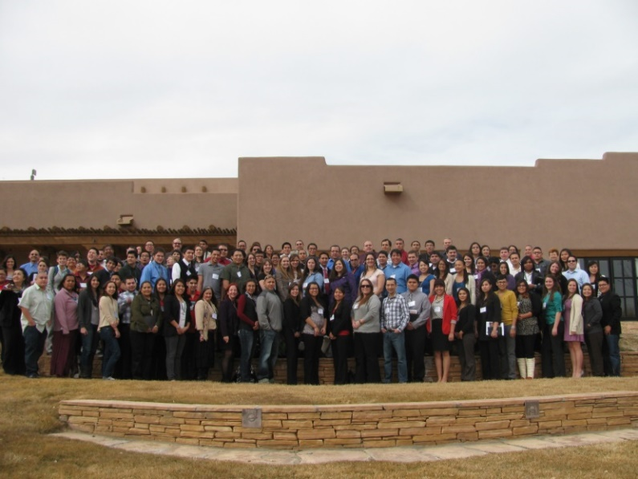

SESSION Proposal and Description: Please fill out completely. Attach additional sheets if needed.

SESSION CONTACT (Will receive all speaker-related communication)
NAME(S) of SPEAKERS
TRIBAL AFFLIATION(S) if applicable
TITLE ________________________________________________
ORGANIZATION/COMPANY ________________________________________________
PHONE _________ E-MAIL (Required) ____________
SESSION TITLE (as you wish it to appear in the program) _______ ____________________________________________________________________________________
SESSION FORMAT (Presentation, Panel, or Interactive session)
TOPIC AREA ____________________________________
DESCRIPTION OF YOUR SESSION for the program booklet. Remember to use language that will engage attendance. Limit 100 words.

SESSION GOAL(S): Explain the intended outcomes of the session and benefits to the audience. Limit 100 words.

LIST 3 LEARNING OBJECTIVES: By the end of the session, participants will be able to…
1.
2.
3.

TARGET AUDIENCE
It is our intention to provide session content that will be interesting and relevant to the many diverse areas of the AISES membership and National Conference attendees. Please indicate session audience. Check all that apply.

Undergraduate & Graduate Students Professionals All Attendees

HANDOUTS/MATERIALS
Will you provide participants with handouts during the session?
Yes (Copies of all handouts must accompany this submission form) No
If yes, description of materials provided to session attendees:

AUDIO/VISUAL

Describe the techonological requirements of your presentation: _____________________________________
__________________________________________________________________________________________

Please list any Audio/Visual Needs:
Microphone
Computer
Projector and Screen
Other:

Deadline for submission of proposals (more than one may be submitted) is
Wednesday, February 10, 2016.
Send this completed form via email, as MS Word file attachment, to: kdeerinwater@aises.org.

