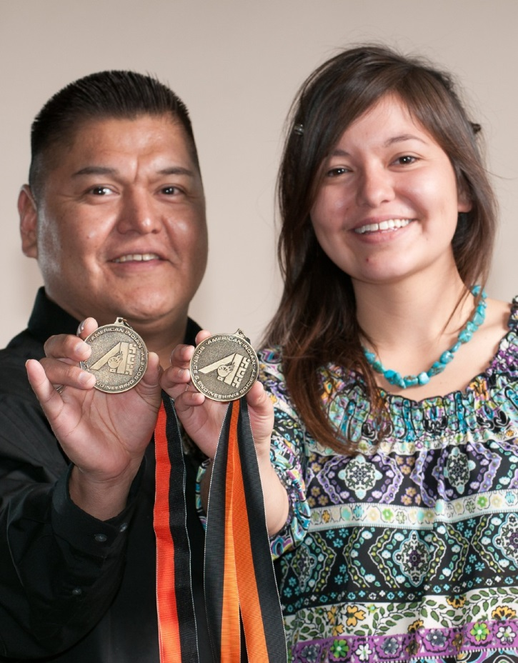
AISES Sequoyah Fellowship

The AISES Lifetime Membership program was named in memory of Sequoyah, the great Cherokee Indian who perfected the Cherokee alphabet and syllabary in 1821, resulting in the Cherokee Nation becoming literate in less than one year.

In this spirit, AISES Sequoyah Fellows are recognized for their commitment to AISES’ mission in STEM and to the American Indian community. They bring honor to AISES by engaging in leadership, mentorship, and other acts of service that support the students and professionals in the AISES family.

Benefits of Sequoyah Fellowship Status
• Lifetime membership in the American Indian Science & Engineering Society
• An engraved medallion exclusive to Sequoyah Fellows
• An ongoing subscription to Winds of Change, AISES’
award-winning quarterly publication
• A permanent inscription on the Sequoyah Honor Roll Plaque displayed at AISES Headquarters
• Recognition at the annual Sequoyah Fellows’ Breakfast taking place at the AISES National Conference
• An opportunity to serve AISES as a leader, mentor, and
role-model

About AISES
Since 1977, AISES has worked to substantially increase American Indian and Alaska Native representation in science, technology, engineering, and math (STEM) fields — as students, professionals, mentors, and leaders. AISES employs a “full circle of support” model that begins with pre-college programs, progresses into collegiate life, and then into the
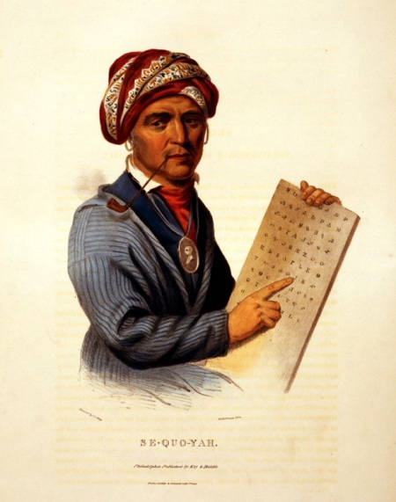
professional years of members and on into retirement.

The mission of the American Indian Science and Engineering Society (AISES) is to sub- stantially increase the representation of American Indians and Alaskan Natives in en- gineering, science, and other related technology disciplines. AISES works to promote, initiate, and provide educational services for American Indian and Alaska Native
pre-college, college, and graduate students in STEM. AISES also supports early-, mid-, and executive-level professionals in STEM through professional development, mentor- ing, networking, community service, and awards programs and initiatives. AISES is the only professional society established by and for American Indian and Alaska Natives that specifically emphasizes lifelong learning and educational achievement by utilizing cultural aspects with STEM.

Questions? Contact the AISES membership department at (505)-765-1052 or membership@aises.org

www.aises.org/membership/life-time
SEQUOYAH FELLOWSHIP PLEDGE AND PAYMENT OPTIONS
Option #1: One-Time Payment in Full of $1,000 (paid by check, money order, cash or credit card) NOTE: Sequoyah Fellowship is not a charitable (tax-deductible) contribution as goods are exchanged (i.e.: lifetime membership and its benefits), in accordance with Federal tax regulations. For this reason, Combined Federal Campaign, employee matching, and other charitable giving programs cannot be used to become a Sequoyah Fellow. AISES welcomes additional charitable contributions to the organization by all members or stakeholders, including Sequoyah Fellows.
Option #2: Twelve-month Pledge (payable over a maximum of twelve months) NOTE: Sequoyah Pledges are not considered Sequoyah Fellows until their obligation is paid in full. A yearly membership fee must be paid until pledges are paid in full. Yearly membership fees already paid to AISES may not be retroactively applied to a Sequoyah Fellowship
Option #3: Donation to AISES from a Sequoyah Fellow
Sequoyah Gifting: A Sequoyah Fellowship given as a “gift” is tax-deductible.
Sequoyah Fellow Information - Please provide ALL information requested below.
Is this a surprise gift? Yes No If yes, individual will not be contacted until after the National Conference.
Name:
Email Address: Phone #:
Address:
City: State: Zip:
We will contact new Sequoyah Fellow with instructions to complete their membership portal account when full payment has been received.

Sequoyah Pledge Payment Information
Name of Donor: Pledging for (name):
Payment Option 1: Check or Money Order (Payable to AISES) Cash Credit Card
Card Type: VISA MC AMEX
Card# Exp. Date: CVV:_______
One Time Charge on _______________________________
Payment Option 2: Charge Card Every: Month starting
In the amount of $
Included with my Sequoyah payment/pledge is a tax-deductible, charitable donation of $________ to assist with the AISES mission.
Payment Option 3: Donation to AISES from a Sequoyah Fellow in the amount of $____________.
There are no refunds for pledges that are not completed within 12 months
Phone: Email:
Address:
Signature: Date:
Full payment, along with a completed Membership Profile should be mailed to:
AISES Sequoyah Fellowship, 6321 Riverside Plaza Lane NW Unit A Albuquerque, NM 87120.

